About us Page
 | Welcome  Warm greetings from Myanmar New Era International Education Centre!  We are proud to offer a quality education through our international education programs. Dive into a world where global perspectives meet exceptional learning experiences. We're excited to embark on this journey with you.
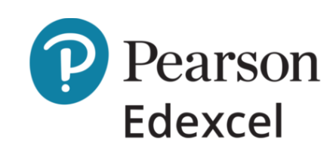 | Our Partners  Pearson Edexcel is one of the UK's largest awarding organizations, providing academic and vocational qualifications. It offers a range of IGCSEs, A-levels, and BTEC courses recognized globally. The organization focuses on enriching the learning experience, ensuring learners are prepared for both academic and professional success.
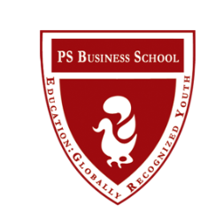 | PS Business School provides a wide range of Business & Management Programs from Foundation level to Master Degree since 2007. It is an approved centre of Pearson BTEC and ABE (UK). Then, it is also an official partner of IU International University of Applied Sciences, Germany to provide Bachelor and Master Degrees.
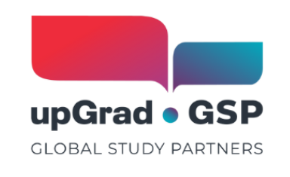 | Global Study Partners (GSP) is a digital platform connecting students with global educational opportunities. Through technology, GSP simplifies the application process, guiding students to suitable courses and institutions, fostering international educational collaboration.
Mission, Vision & Core Values

Mission  To deliver high-quality English programmes that strengthen communication, academic skills, and confidence for study and work. | Vision  To be a trusted international education community in Myanmar—a bridge to global learning and positive growth for every student we serve. | Core Values  Quality teaching & learner progress  International curriculum & partnerships  Inclusive, respectful learning community  Integrity and professionalism
Facilities

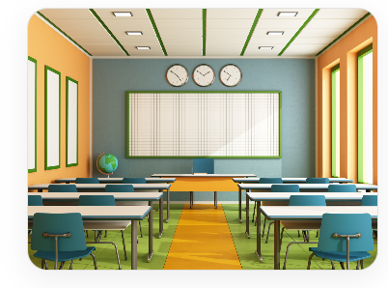  Modern Classrooms  Comfortable classrooms designed for effective and interactive learning. | 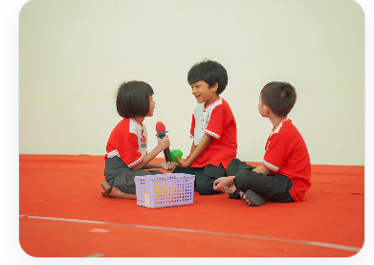  Speaking Practice Sessions  Students participate in group discussions and speaking activities to improve fluency. | 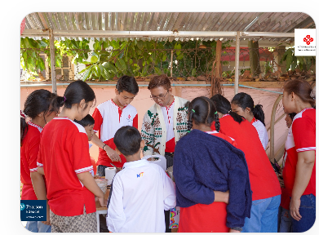  Student Activities  Regular learning activities and events that help students practice English in real situations.
Join Myanmar New Era

Create your new future with English.

At Myanmar New Era International Education Centre, we are committed to helping students achieve their goals and build confidence in using English in everyday life.

Take Free Placement Test

